1. Write a Java swings program to demonstrate a login page with action listener.

**import** java.awt.Color;

**import** java.awt.event.ActionEvent;

**import** java.awt.event.ActionListener;

**import** javax.swing.*;

**public** **class** login {

**public** **static** **void** main(String args[])

{

JFrame j=**new** JFrame("Login Page");

JLabel l1=**new** JLabel("Enter Username");

JLabel l2=**new** JLabel("Enter Password");

**final** JTextField t=**new** JTextField();

**final** JPasswordField p=**new** JPasswordField();

JButton b=**new** JButton("Sign up");

l1.setBounds(10, 50, 100, 30);

l2.setBounds(10, 100, 100, 30);

t.setBounds(120, 50, 120, 30);

p.setBounds(120, 100, 120, 30);

b.setBounds(100, 150, 80, 30);

j.getContentPane().setBackground(Color.*CYAN*);

b.setBackground(Color.*ORANGE*);

j.add(l1);

j.add(l2);

j.add(t);

j.add(p);

j.add(b);

b.addActionListener(**new** ActionListener()

{

**public** **void** actionPerformed(ActionEvent e) {

**if**(t.getText().equals("admin")&&p.~~getText~~().equals("pass"))

{

JOptionPane.*showMessageDialog*(**null**, "Welcome");

}

**else**

{

JOptionPane.*showMessageDialog*(**null**, "Invalid");

}

}

});

j.setSize(500,500);

j.setLayout(**null**);

j.setVisible(**true**);

}

}

**Output:**

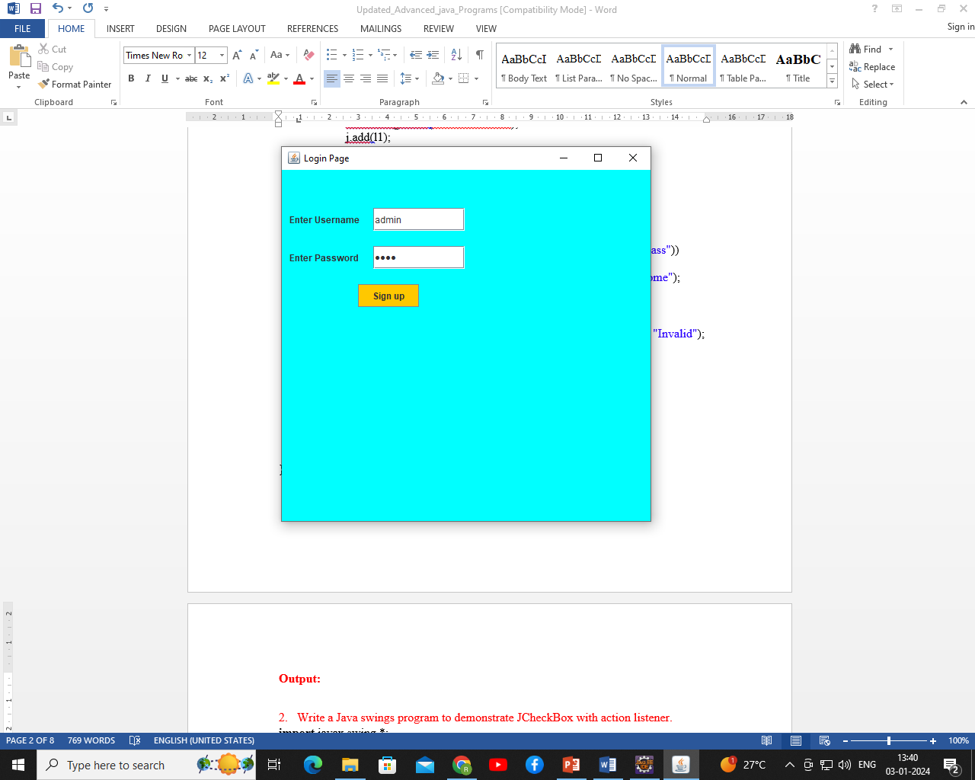

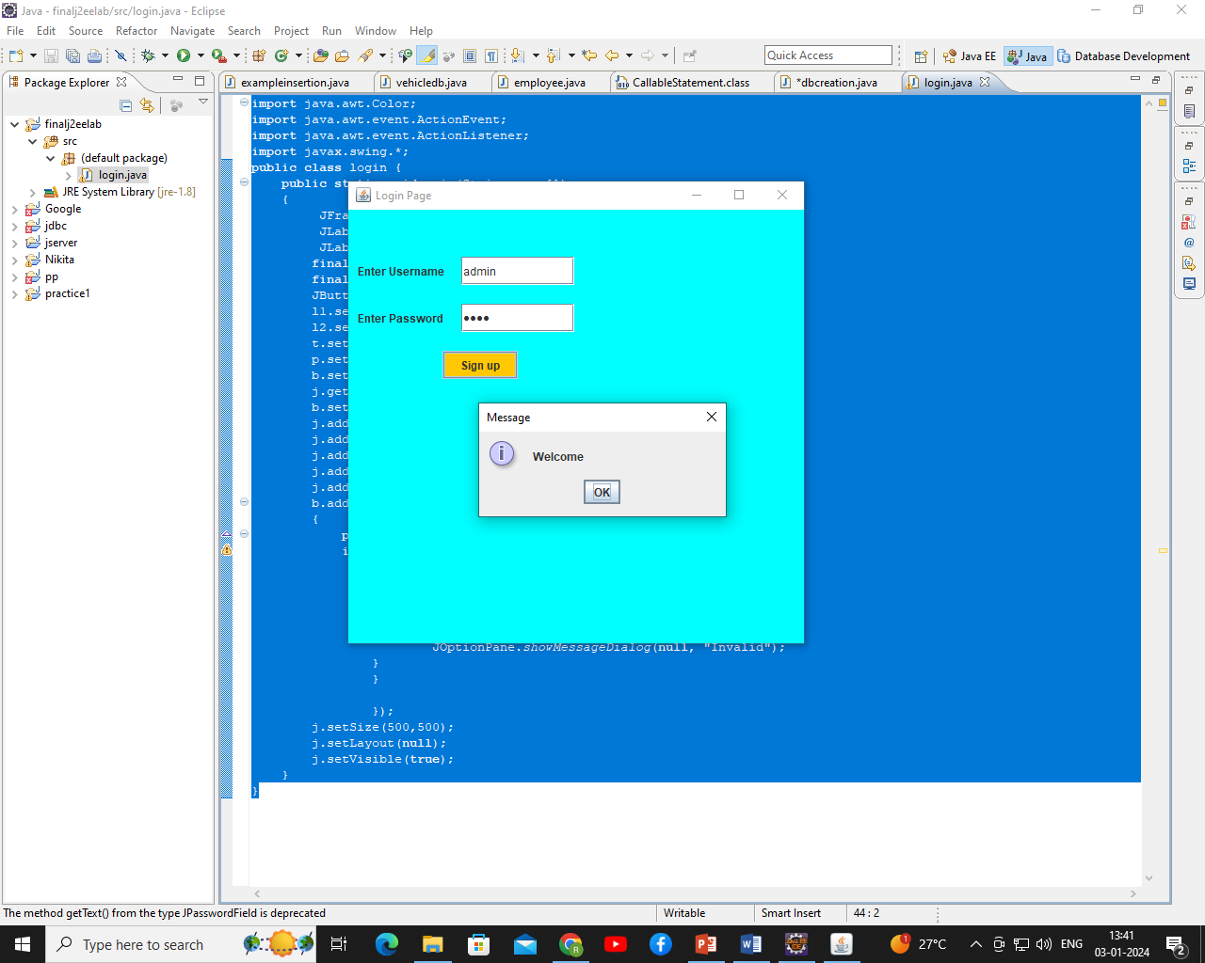

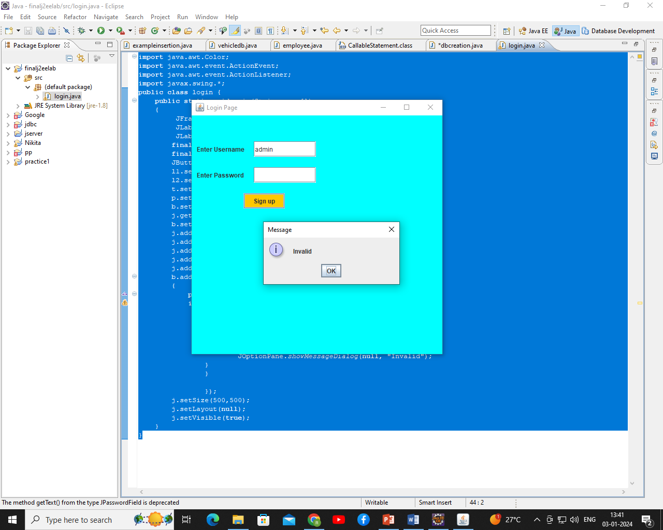

1. Write a Java swings program to demonstrate JCheckBox with action listener.

**import** javax.swing.*;

**import** java.awt.event.*;

**public** **class** CheckBoxExample **extends** JFrame **implements** ActionListener{

    JLabel l;

    JCheckBox cb1,cb2,cb3;

    JButton b;

    CheckBoxExample(){

        l=**new** JLabel("Food Ordering System");

        l.setBounds(50,50,300,20);

        cb1=**new** JCheckBox("Pizza @ 100");

        cb1.setBounds(100,100,150,20);

        cb2=**new** JCheckBox("Burger @ 30");

        cb2.setBounds(100,150,150,20);

        cb3=**new** JCheckBox("Tea @ 10");

        cb3.setBounds(100,200,150,20);

        b=**new** JButton("Order");

        b.setBounds(100,250,80,30);

        b.addActionListener(**this**);

        add(l);add(cb1);add(cb2);add(cb3);add(b);

        setSize(400,400);

        setLayout(**null**);

        setVisible(**true**);

        setDefaultCloseOperation(EXIT_ON_CLOSE);

    }

**public** **void** actionPerformed(ActionEvent e){

**float** amount=0;

        String msg="";

**if**(cb1.isSelected()){

            amount+=100;

            msg="Pizza: 100\n";

        }

**if**(cb2.isSelected()){

            amount+=30;

            msg+="Burger: 30\n";

        }

**if**(cb3.isSelected()){

            amount+=10;

            msg+="Tea: 10\n";

        }

        msg+="-----------------\n";

        JOptionPane.showMessageDialog(**this**,msg+"Total: "+amount);

    }

**public** **static** **void** main(String[] args) {

**new** CheckBoxExample();

    }

}

**Output:**

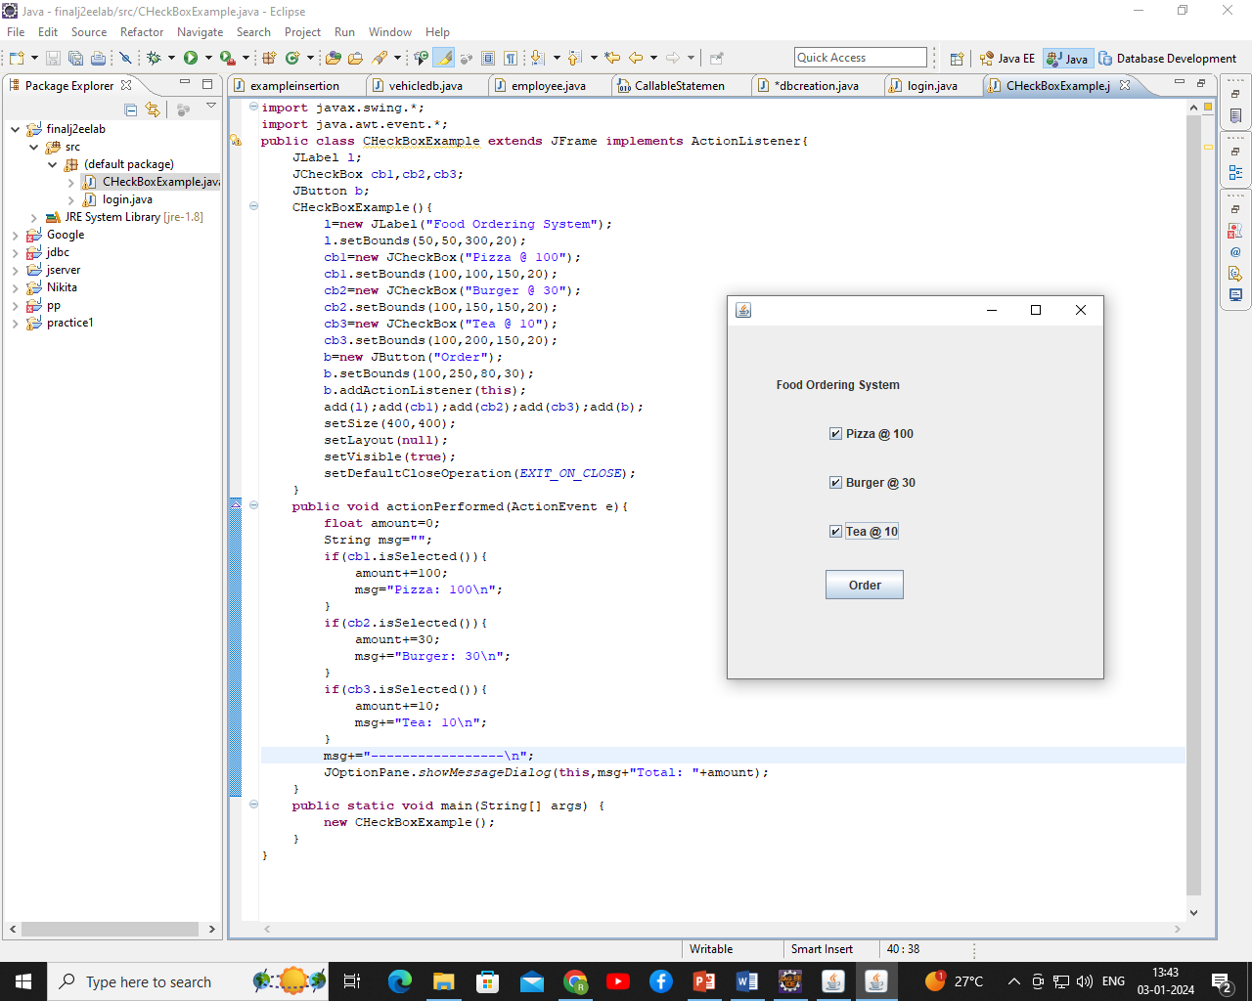

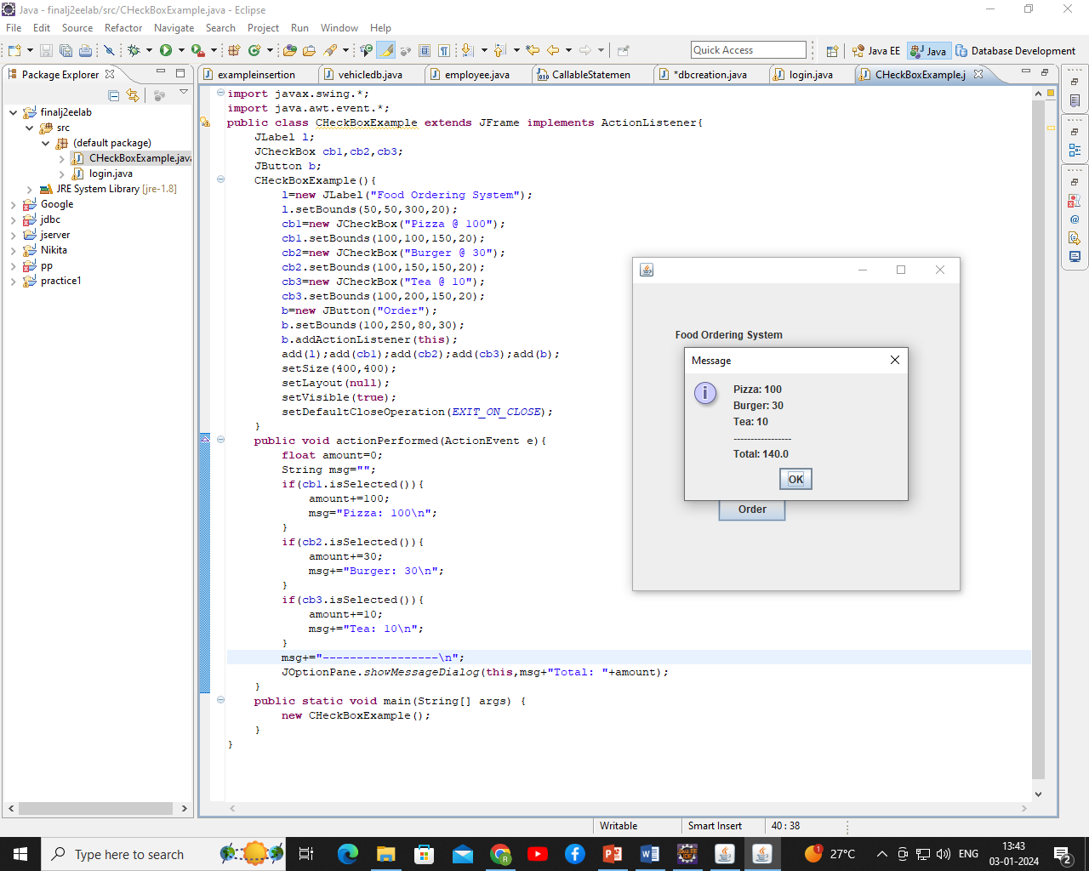

1. Write a Java swings program to demonstrate JRadioButton with action listener.

**import** javax.swing.*;

**import** java.awt.event.*;

**class** RadioButtonExample **extends** JFrame **implements** ActionListener{

JRadioButton rb1,rb2;

JButton b;

RadioButtonExample(){

rb1=**new** JRadioButton("Male");

rb1.setBounds(100,50,100,30);

rb2=**new** JRadioButton("Female");

rb2.setBounds(100,100,100,30);

ButtonGroup bg=**new** ButtonGroup();

bg.add(rb1);bg.add(rb2);

b=**new** JButton("click");

b.setBounds(100,150,80,30);

b.addActionListener(**this**);

add(rb1);add(rb2);add(b);

setSize(300,300);

setLayout(**null**);

setVisible(**true**);

}

**public** **void** actionPerformed(ActionEvent e){

**if**(rb1.isSelected()){

JOptionPane.showMessageDialog(**this**,"You are Male.");

}

**if**(rb2.isSelected()){

JOptionPane.showMessageDialog(**this**,"You are Female.");

}

}

**public** **static** **void** main(String args[]){

**new** RadioButtonExample();

}

}

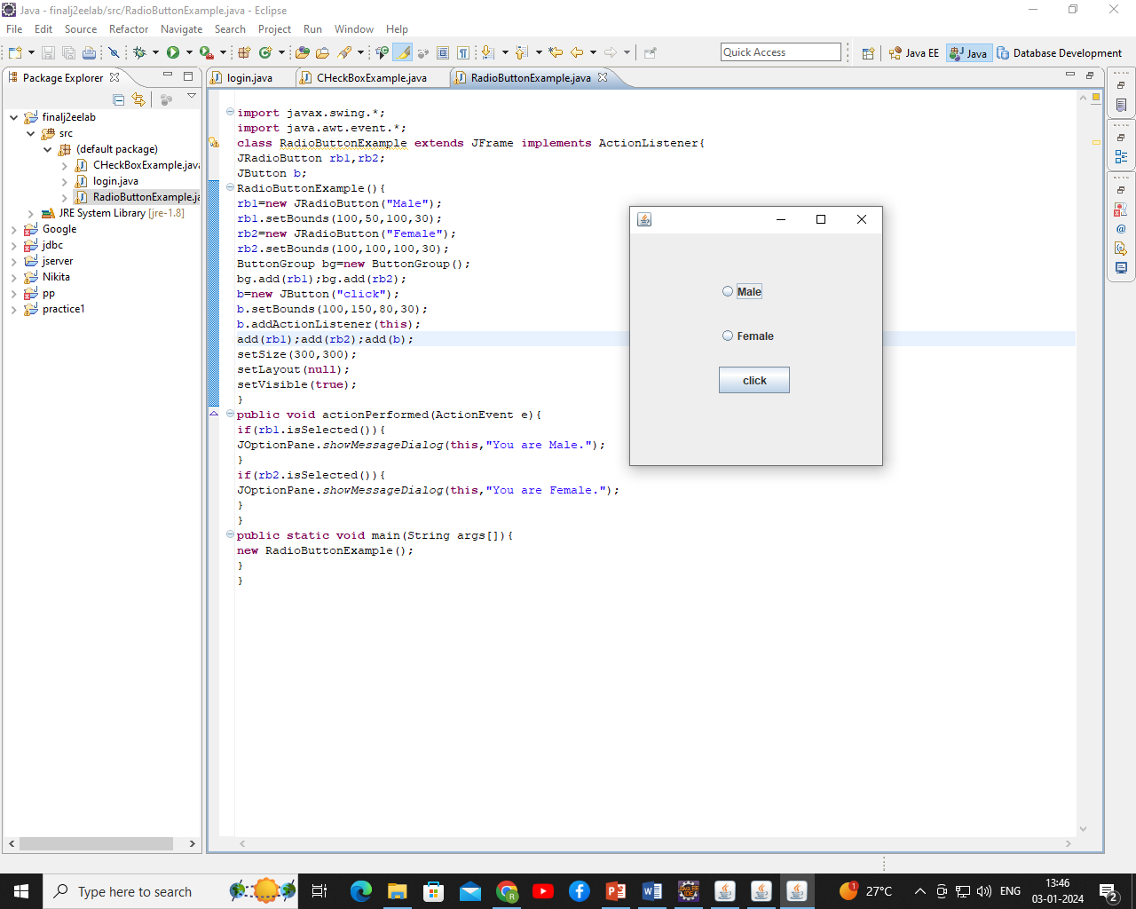

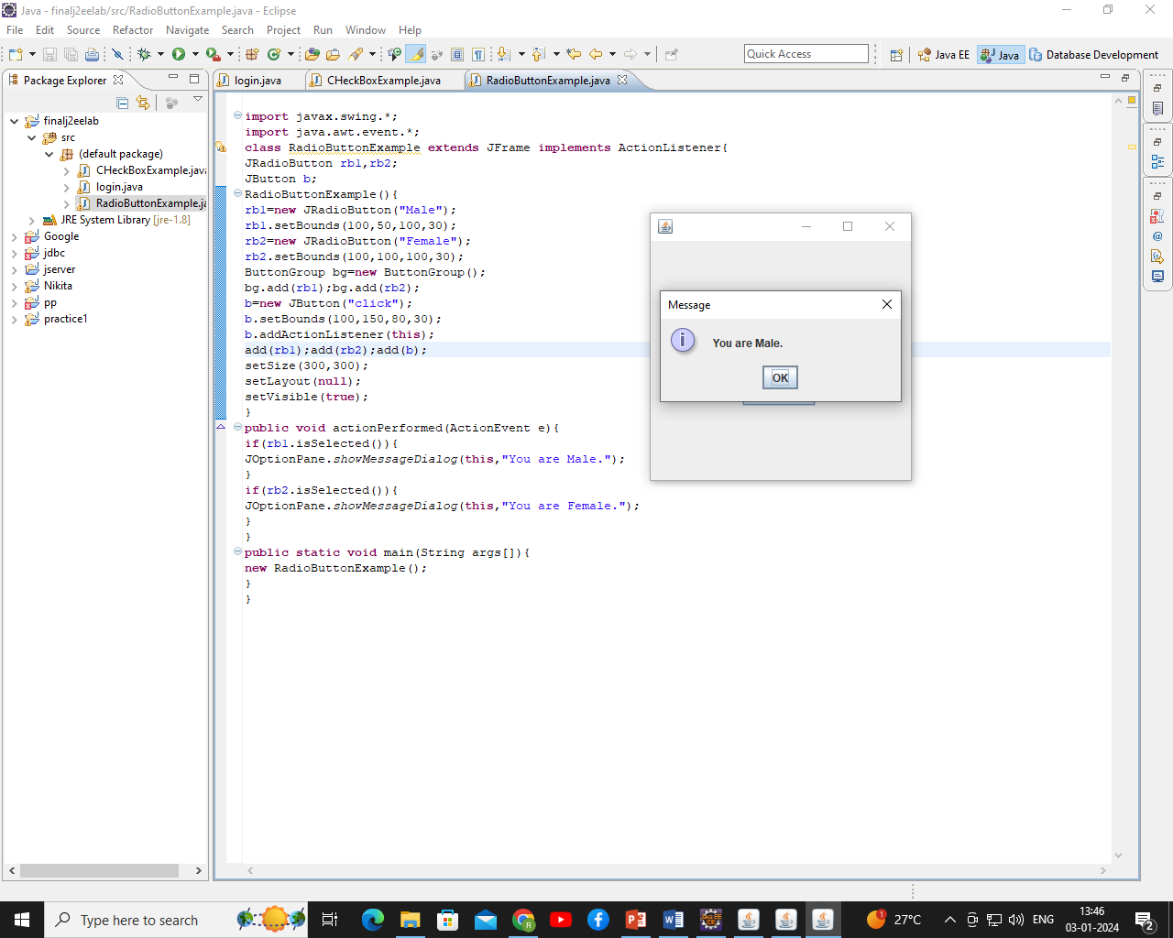

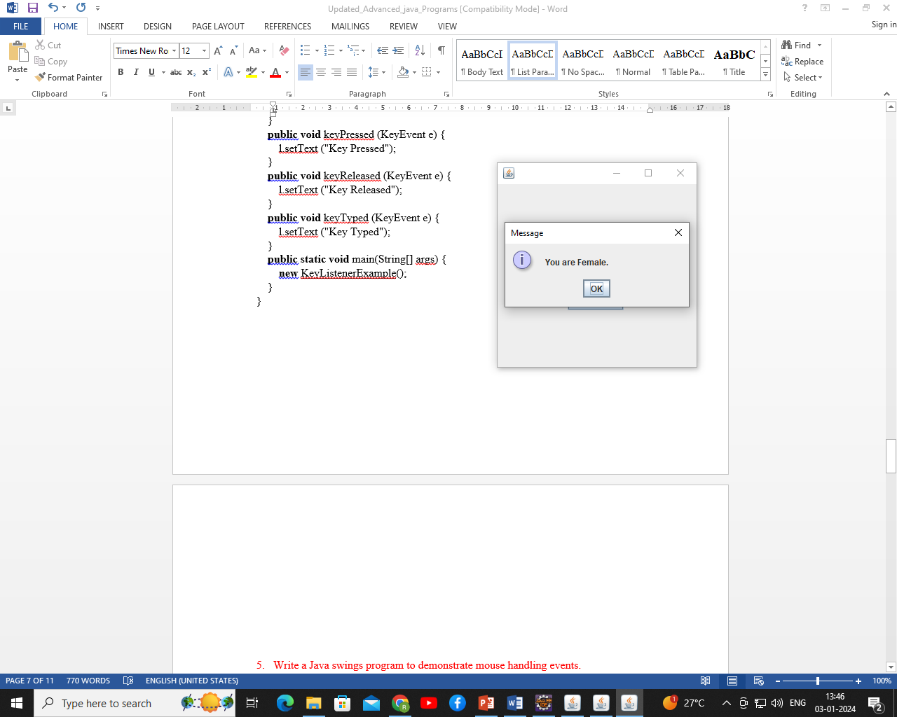

1. Write a Java swings program to demonstrate key board handling events.

**import** javax.swing.*;

**import** java.awt.event.*;

**public** **class** KeyListenerExample **extends** JFrame **implements** KeyListener {

JLabel l;

JTextArea area;

KeyListenerExample() {

l = **new** JLabel();

l.setBounds (20, 50, 100, 20);

area = **new** JTextArea();

area.setBounds (20, 80, 300, 300);

area.addKeyListener(**this**);

add(l);

add(area);

setSize (500, 500);

setLayout (**null**);

setVisible (**true**);

}

**public** **void** keyPressed (KeyEvent e) {

l.setText ("Key Pressed");

}

**public** **void** keyReleased (KeyEvent e) {

l.setText ("Key Released");

}

**public** **void** keyTyped (KeyEvent e) {

l.setText ("Key Typed");

}

**public** **static** **void** main(String[] args) {

**new** KeyListenerExample();

}

}

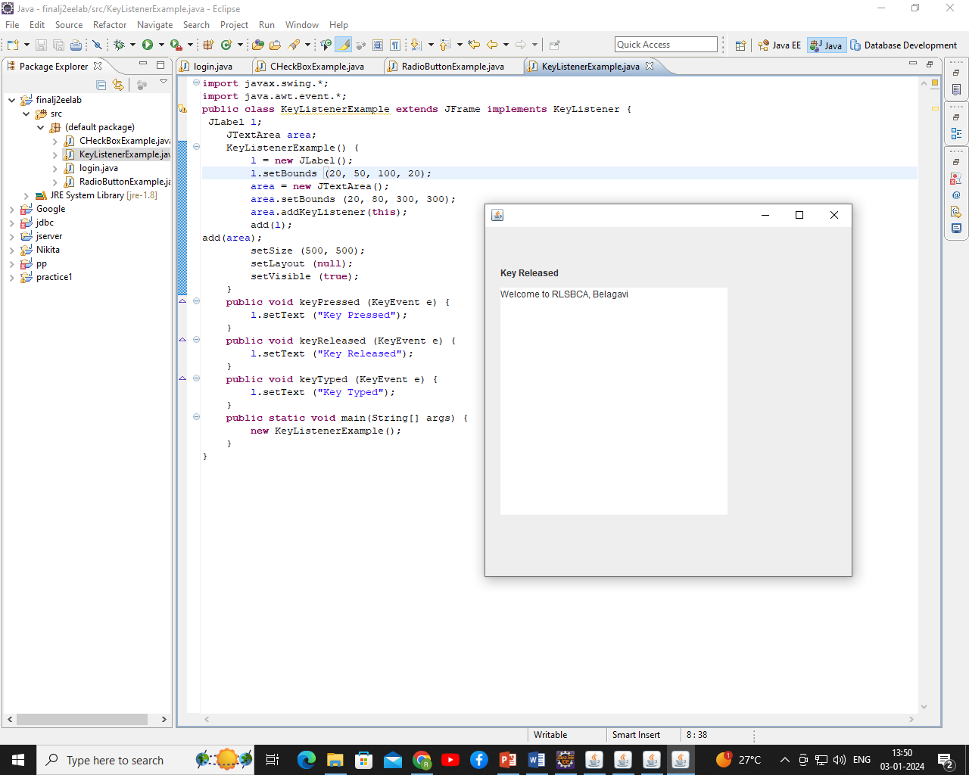

1. Write a Java swings program to demonstrate mouse handling events.

**import** javax.swing.*;

**import** java.awt.event.*;

**public** **class** MouseListenerExample **extends** JFrame **implements** MouseListener{

JLabel l;

MouseListenerExample(){

addMouseListener(**this**);

l=**new** JLabel();

l.setBounds(20,50,100,20);

add(l);

setSize(300,300);

setLayout(**null**);

setVisible(**true**);

}

**public** **void** mouseClicked(MouseEvent e) {

l.setText("Mouse Clicked");

}

**public** **void** mouseEntered(MouseEvent e) {

l.setText("Mouse Entered");

}

**public** **void** mouseExited(MouseEvent e) {

l.setText("Mouse Exited");

}

**public** **void** mousePressed(MouseEvent e) {

l.setText("Mouse Pressed");

}

**public** **void** mouseReleased(MouseEvent e) {

l.setText("Mouse Released");

}

**public** **static** **void** main(String[] args) {

**new** MouseListenerExample();

}

}

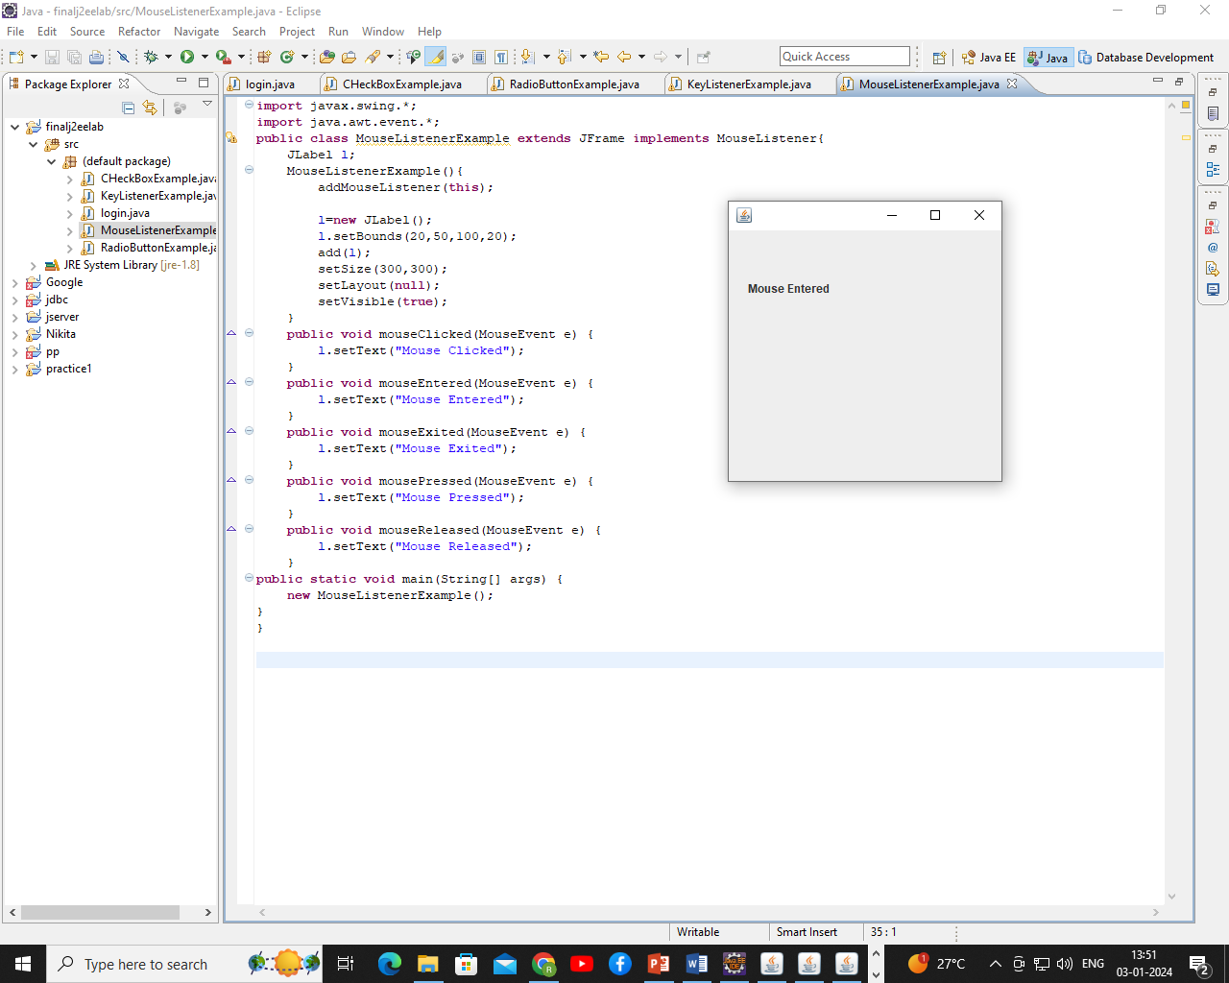

1. Write a Java swings program to demonstrate JComboBox with action listener.

**import** javax.swing.*;

**import** java.awt.event.*;

**public** **class** ComboBoxExample {

JFrame f;

ComboBoxExample(){

    f=**new** JFrame("ComboBox Example");

**final** JLabel label = **new** JLabel();

    label.setHorizontalAlignment(JLabel.CENTER);

    label.setSize(400,100);

    JButton b=**new** JButton("Show");

    b.setBounds(200,100,75,20);

    String languages[]={"C","C++","C#","Java","PHP"};

**final** JComboBox cb=**new** JComboBox(languages);

    cb.setBounds(50, 100,90,20);

    f.add(cb); f.add(label); f.add(b);

    f.setLayout(**null**);

    f.setSize(350,350);

    f.setVisible(**true**);

    b.addActionListener(**new** ActionListener() {

**public** **void** actionPerformed(ActionEvent e)

{

String data = "Programming language Selected: "

   + cb.getItemAt(cb.getSelectedIndex());

label.setText(data);

}

});

}

**public** **static** **void** main(String[] args) {

**new** ComboBoxExample();

}

}

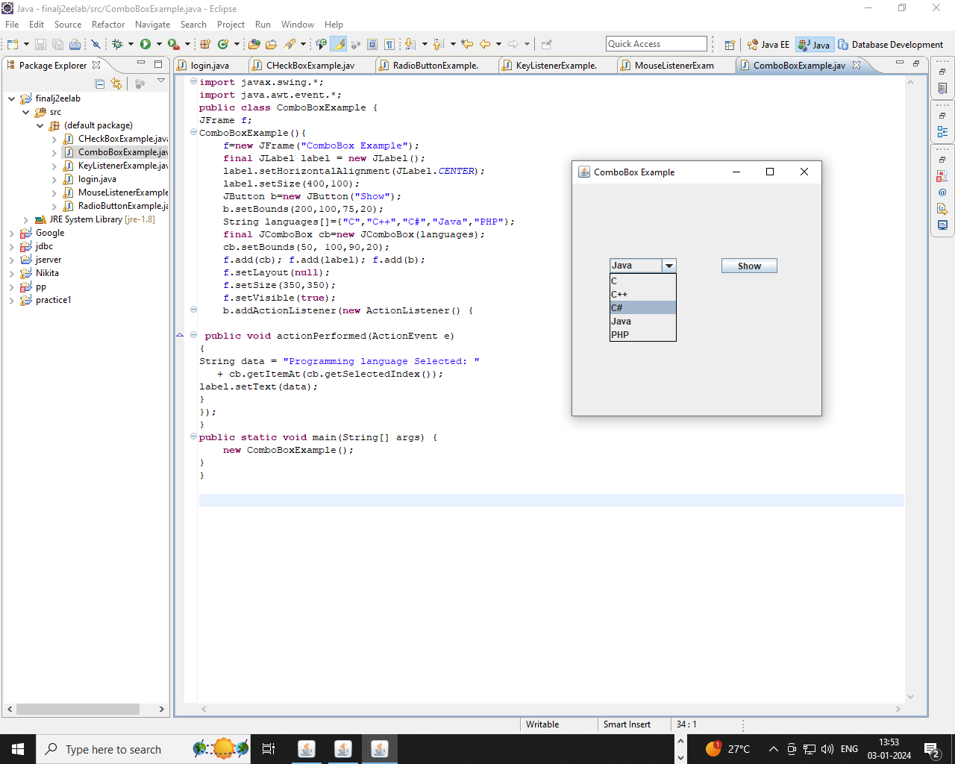

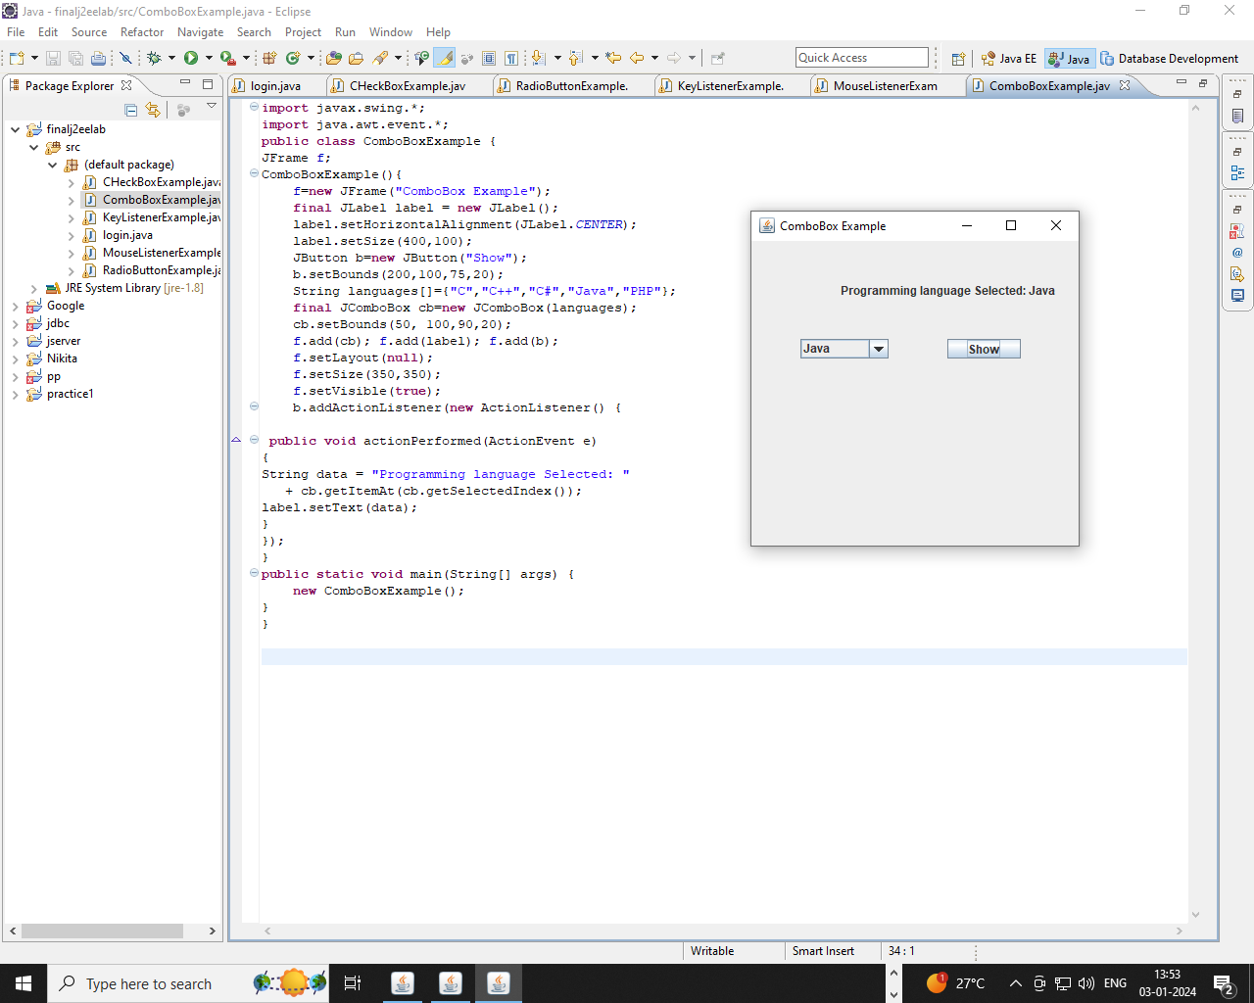

1. Write a Java swings program to demonstrate JTable.

**import** javax.swing.*;

**public** **class** JtableEx {

**public** **static** **void** main(String[] a) {

JFrame frame = **new** JFrame();

**final** JTable table;

String[] columnTitles = { "A", "B", "C", "D" };

Object[][] rowData = { { "11", "12", "13", "14" }, { "21", "22", "23", "24" },

{ "31", "32", "33", "34" }, { "41", "42", "44", "44" } };

table = **new** JTable(rowData, columnTitles);

frame.add(**new** JScrollPane(table));

frame.setSize(300, 200);

frame.setVisible(**true**);

}

}

**Output:**

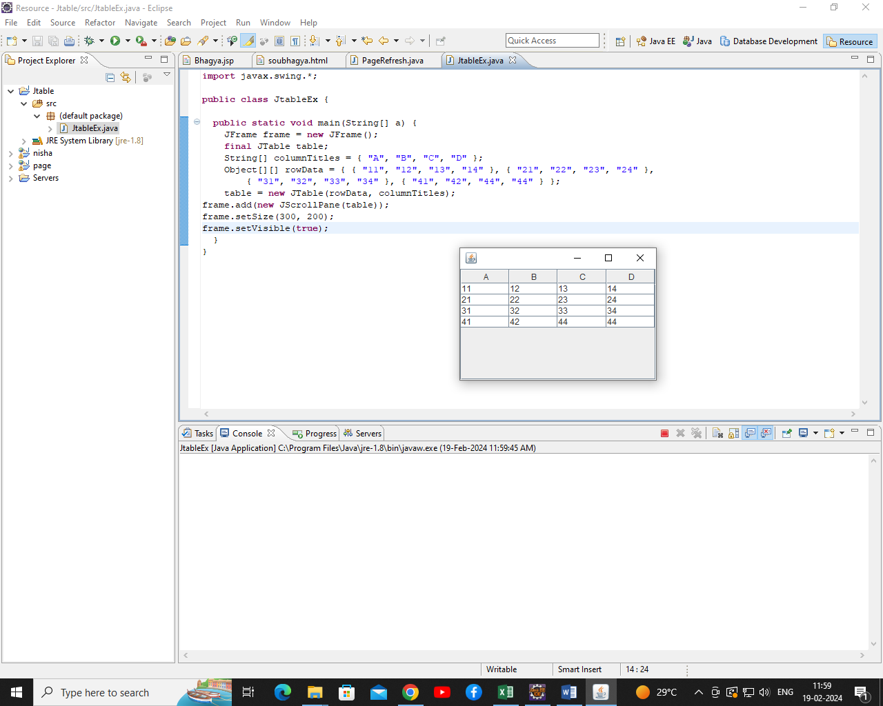

1. Write a Java swings program to demonstrate JScrollBar with adjustment listener.

**import** javax.swing.*;

**import** java.awt.event.*;

**class** scrollex

{

scrollex(){

JFrame f= **new** JFrame("Scrollbar Example");

**final** JLabel label = **new** JLabel();

label.setHorizontalAlignment(JLabel.*CENTER*);

label.setSize(400,100);

**final** JScrollBar s=**new** JScrollBar();

s.setBounds(50,100, 50,300);

f.add(s); f.add(label);

f.setSize(500,500);

f.setLayout(**null**);

f.setVisible(**true**);

s.addAdjustmentListener(**new** AdjustmentListener() {

**public** **void** adjustmentValueChanged(AdjustmentEvent e) {

label.setText("Vertical Scrollbar value is:"+ s.getValue());

}

});

}

**public** **static** **void** main(String args[])

{

**new** scrollex();

}}

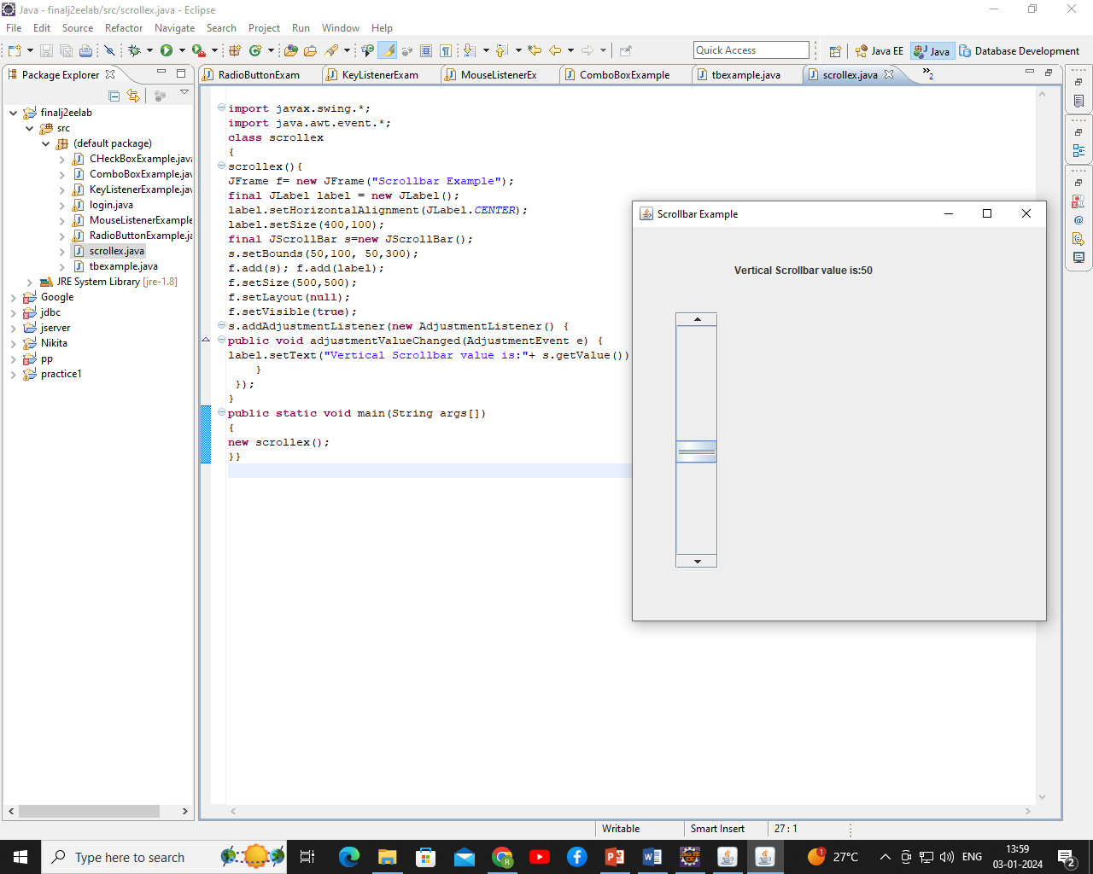

**Steps for Reference: (Don’t write in Journal)**

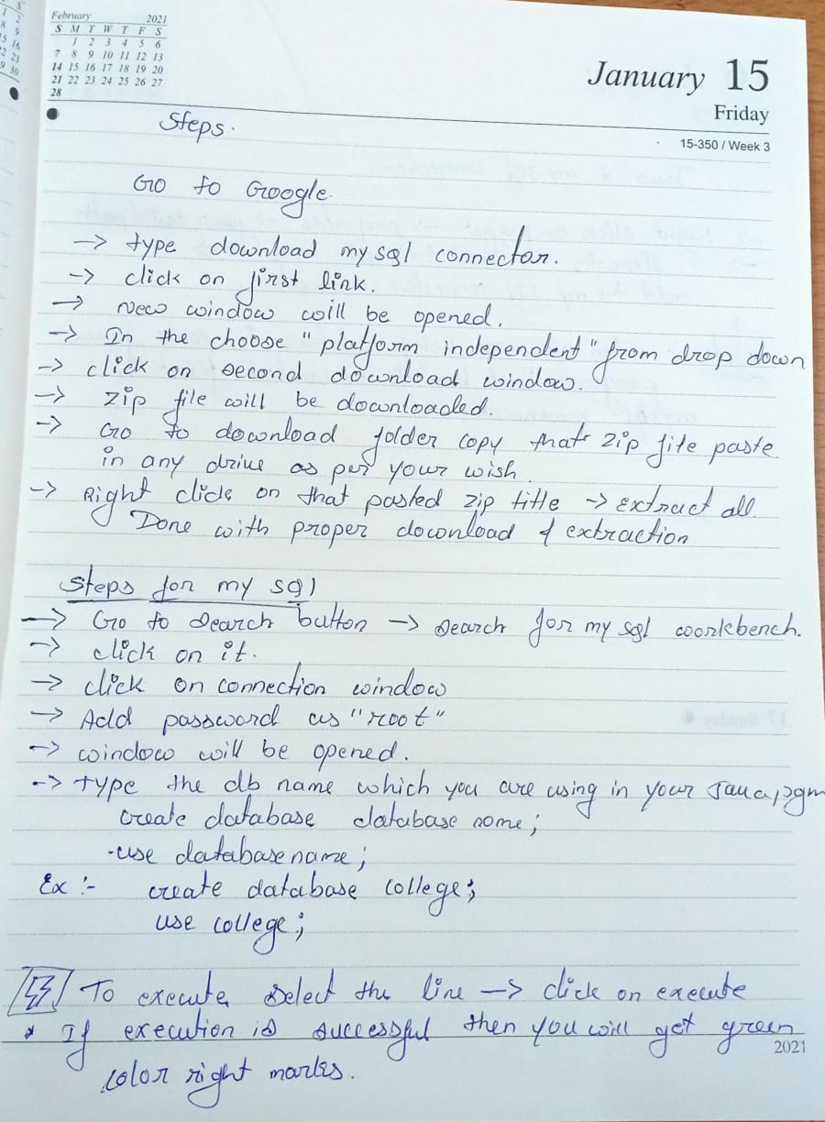

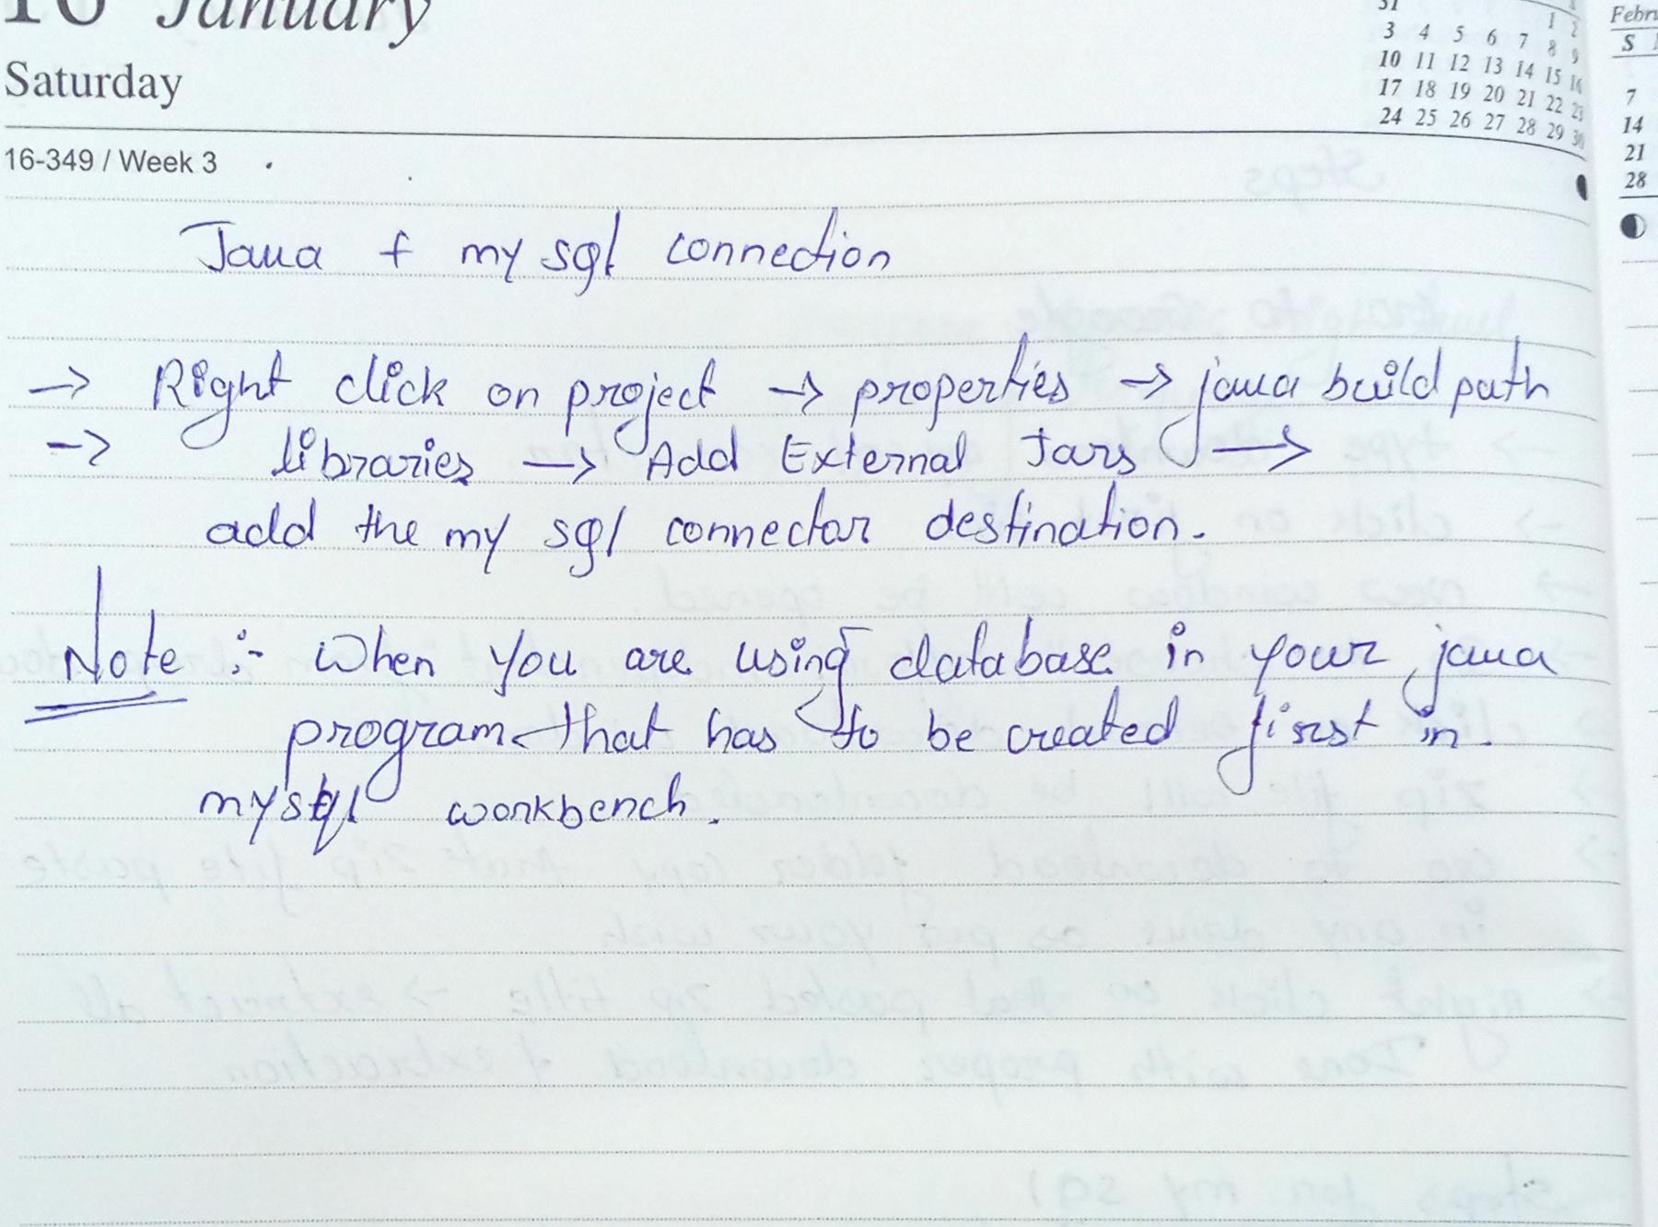

1. **Write a JDBC Program to perform following operations**
2. **Creation of database**
3. **Creation of table**
4. **Insertion of 5 values to the table**

**import** java.sql.*;

**public** **class** dbcreation

{

**public** **static** **void** main(String args[]) **throws** Exception

{

Connection conn=**null**;

Statement stmt=**null**;

Class.*forName*("com.mysql.jdbc.Driver");

conn = DriverManager.*getConnection*("jdbc:mysql://localhost:3306/movie","root", "root");

stmt = conn.createStatement();

//String sql = "create database movie";

//String sql = "create table actor(actid int primary key,actname varchar(20))";

//String sql = "insert into actor values(101,'Yash')";

String sql1 = "insert into actor values(102,'Aditi')";

String sql2 = "insert into actor values(103,'Hritik')";

String sql3 = "insert into actor values(104,'Genelia')";

String sql4 = "insert into actor values(105,'Rajani')";

// stmt.executeUpdate(sql);

stmt.executeUpdate(sql1);

stmt.executeUpdate(sql2);

stmt.executeUpdate(sql3);

stmt.executeUpdate(sql4);

System.*out*.println("Successfully Done");

stmt.close();

conn.close();

}

}

**Output:**

Successfully Done

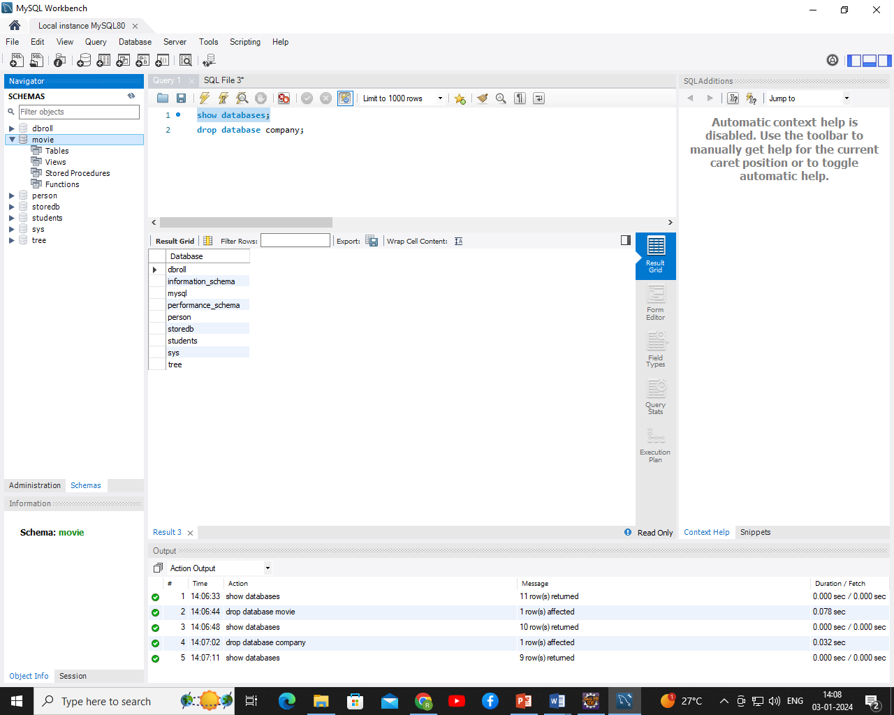

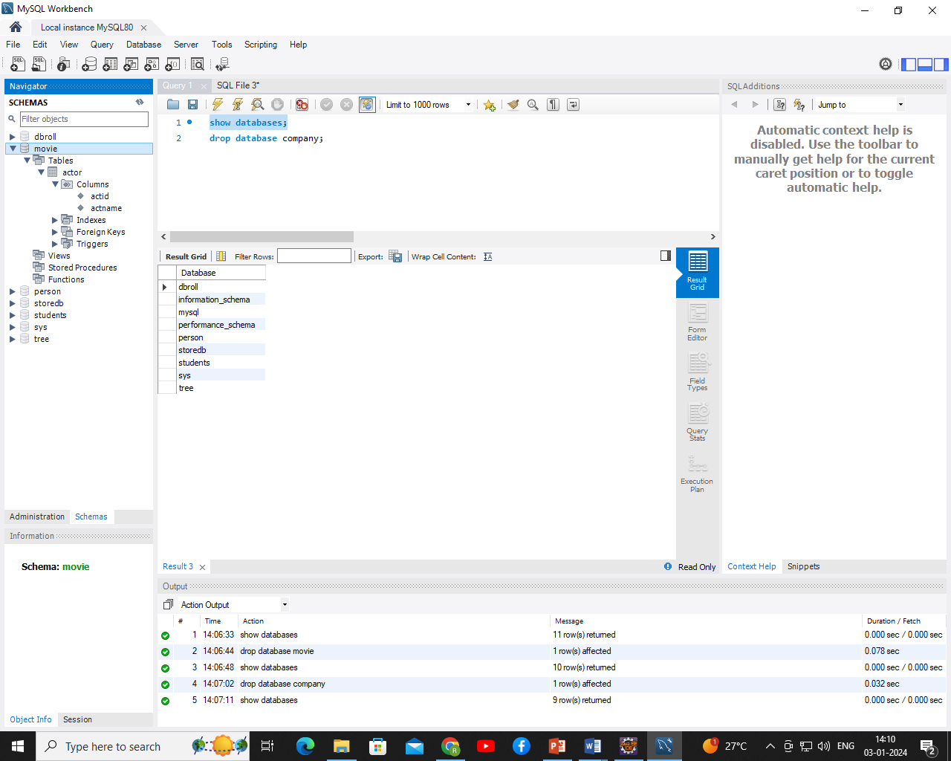

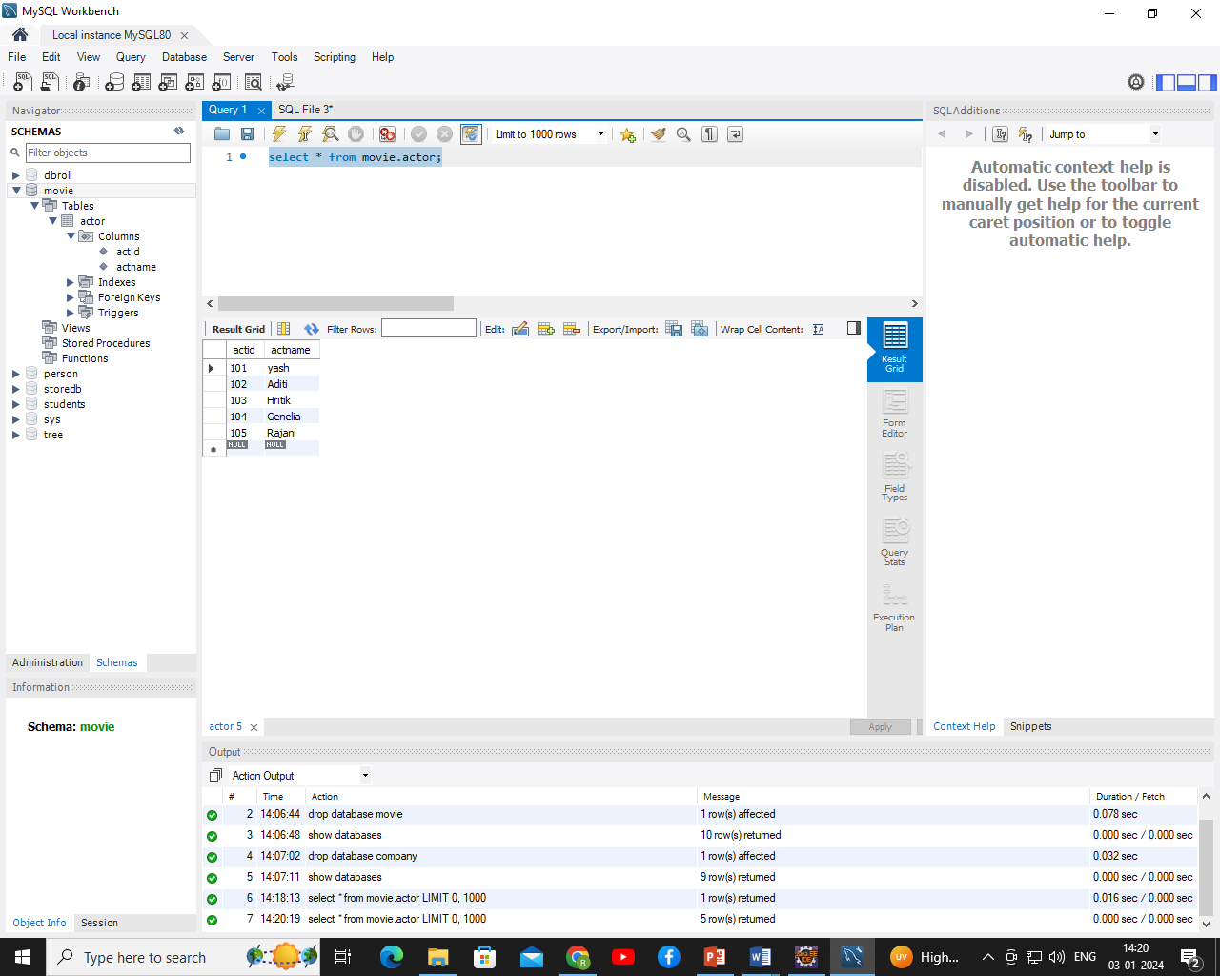

1. **Write a JDBC program to demonstrate Insertion and Deletion Operation.**

**Backend Code:**

create database college;

use college;

create table student(studid int primary key,name varchar(20));

**Frontend Code**:

**import** java.sql.*;

**public** **class** dbcreation

{

**public** **static** **void** main(String args[]) **throws** Exception

{

Connection conn=**null**;

Statement stmt=**null**;

Class.*forName*("com.mysql.jdbc.Driver");

conn = DriverManager.*getConnection*("jdbc:mysql://localhost:3306/college","root", "root");

stmt = conn.createStatement();

// String sql = "insert into student values(21,'Ankita')";

//String sql1 = "insert into student values(22,'Omkar')";

//String sql2 = "insert into student values(23,'Anuradha')";

//String sql3 = "insert into student values(24,'suhani')";

//String sql4 = "insert into student values(25,'Sanjana')";

//stmt.executeUpdate(sql);

//stmt.executeUpdate(sql1);

//stmt.executeUpdate(sql2);

//stmt.executeUpdate(sql3);

// stmt.executeUpdate(sql4);

String del="delete from student where studid=21";

stmt.executeUpdate(del);

System.*out*.println("Successfully Done");

stmt.close();

conn.close();

}

}

**Output:**

Successfully Done

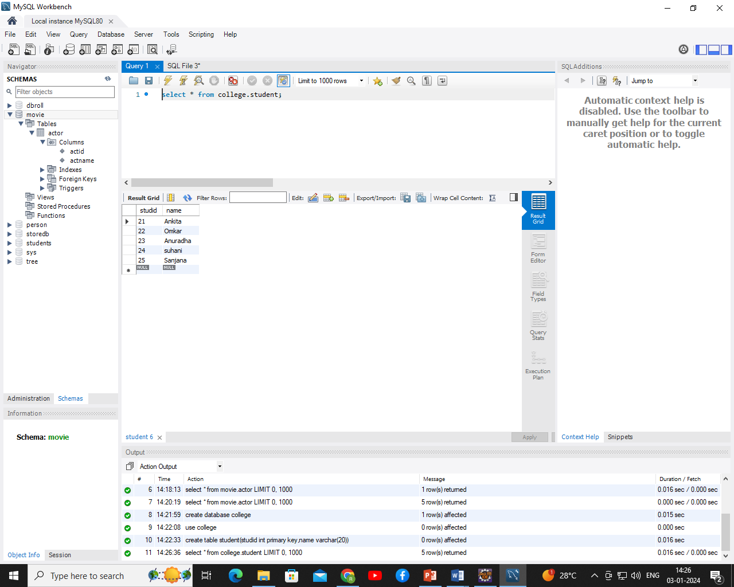

Successfully Done

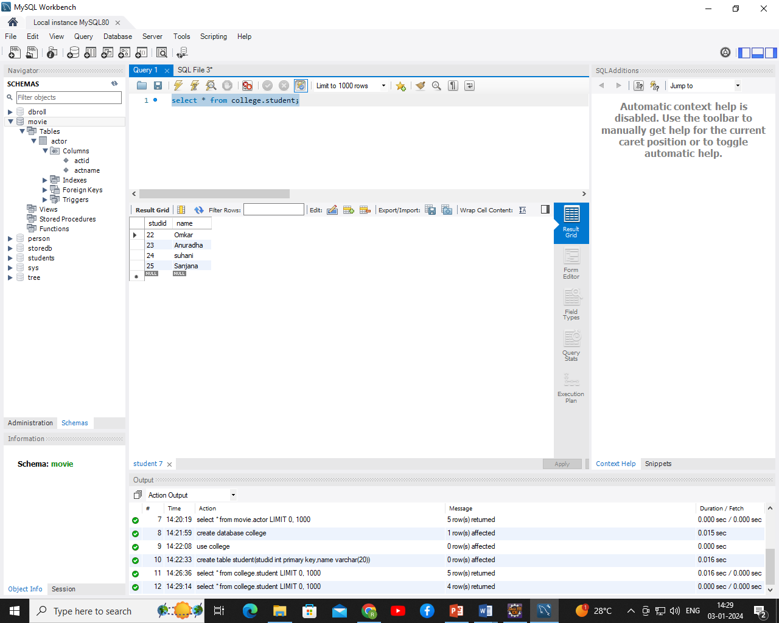

Record deleted from backend.

1. **Write a JDBC program to demonstrate Insert and Update Operation.**

**Backend Code:**

create database insurance;

use insurance;

create table car(regno varchar(20),ownername varchar(25));

**Front End Code:**

**import** java.sql.*;

**public** **class** dbcreation

{

**public** **static** **void** main(String args[]) **throws** Exception

{

Connection conn=**null**;

Statement stmt=**null**;

Class.*forName*("com.mysql.jdbc.Driver");

conn = DriverManager.*getConnection*("jdbc:mysql://localhost:3306/insurance","root", "root");

stmt = conn.createStatement();

// String sql = "insert into car values('ka22a1234','Ankita')";

//String sql1 = "insert into car values('ka23a1234','Omkar')";

// String sql2 = "insert into car values('ka24a1234','Anuradha')";

// String sql3 = "insert into car values('ka25a1234','suhani')";

// String sql4 = "insert into car values('ka26a1234','Sanjana')";

// stmt.executeUpdate(sql);

// stmt.executeUpdate(sql1);

// stmt.executeUpdate(sql2);

// stmt.executeUpdate(sql3);

//stmt.executeUpdate(sql4);

String update="update car set ownername='Bhagya' where regno='ka22a1234'";

stmt.executeUpdate(update);

System.*out*.println("Successfully Done");

stmt.close();

conn.close();

}

}

Output:

select * from insurance.car;

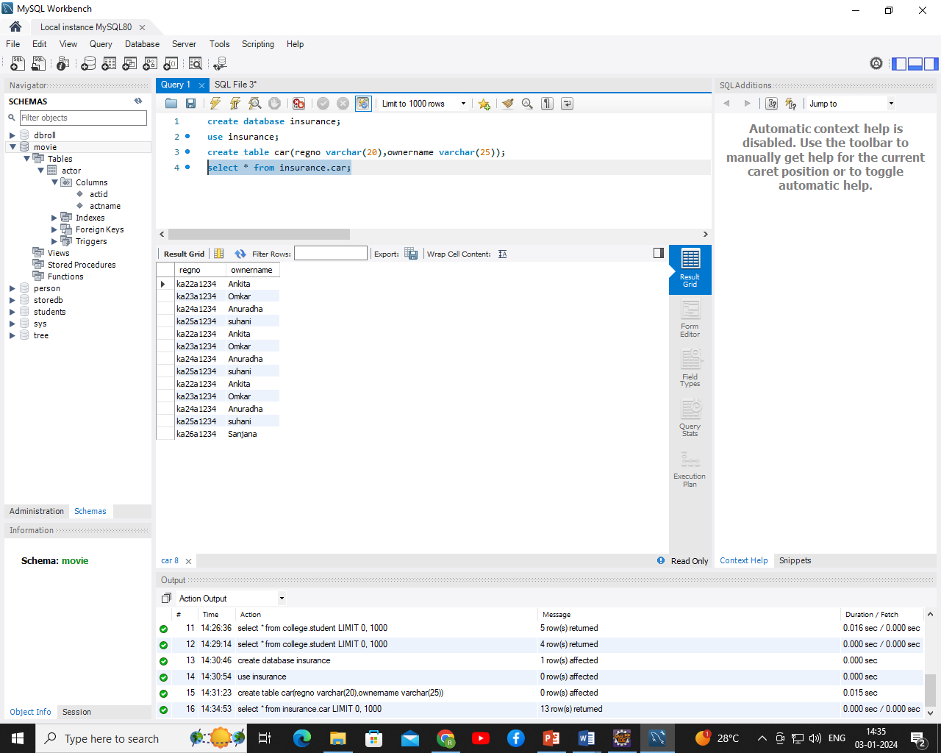

select * from insurance.car;

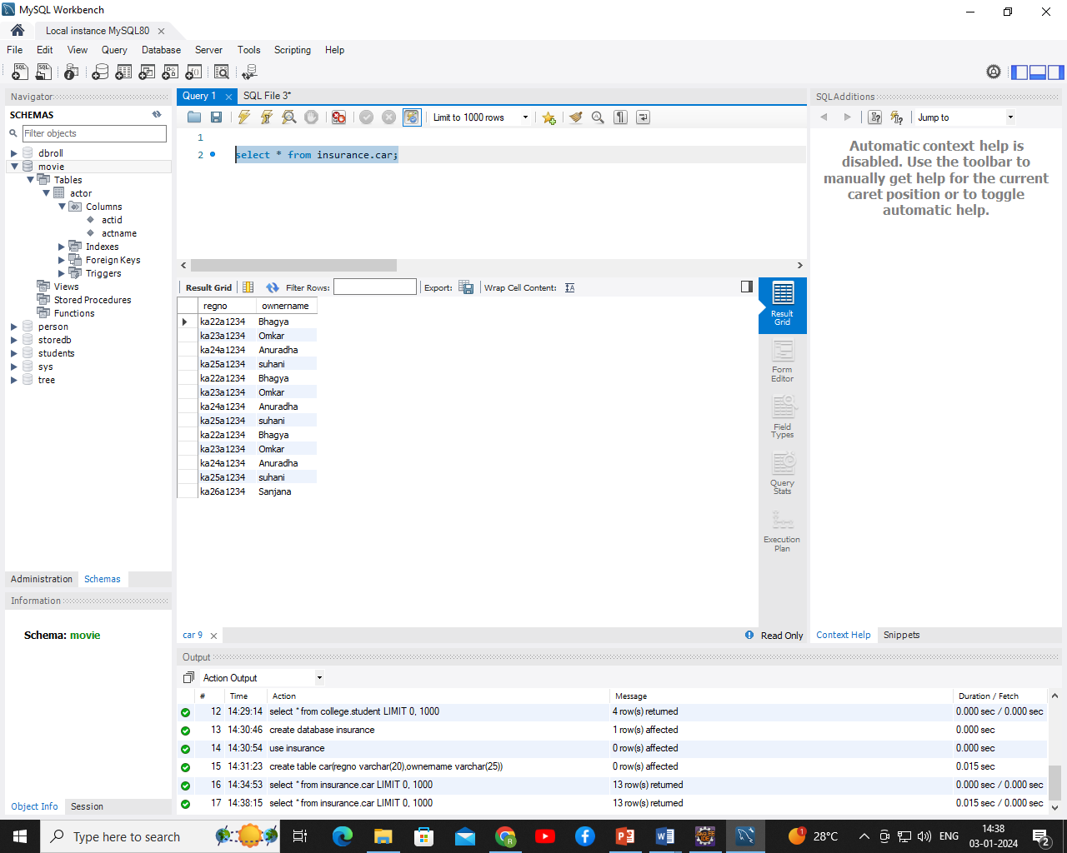

1. **Write a JDBC program to demonstrate fetch the values from backend to frontend.**

**Backend Code:**

create database company;

use company;

create table employee(empid int,empname varchar(20),salary int);

insert into employee values(1001,'Pallavi',45000);

insert into employee values(1002,'Bhagya',55000);

insert into employee values(1003,'Aditi',25000);

insert into employee values(1004,'Nisha',65000);

insert into employee values(1005,'Sahana',95000);

**Frontend Code:**

**import** java.sql.*;

**public** **class** dbcreation

{

**public** **static** **void** main(String args[]) **throws** Exception

{

Connection conn=**null**;

Statement stmt=**null**;

Class.*forName*("com.mysql.jdbc.Driver");

conn = DriverManager.*getConnection*("jdbc:mysql://localhost:3306/company","root", "root");

stmt = conn.createStatement();

ResultSet rs=stmt.executeQuery("Select * from employee");

**while**(rs.next())

{

System.*out*.println("Empid:"+rs.getString(1));

System.*out*.println("Emp Name:"+rs.getString(2));

System.*out*.println("Emp Salary:"+rs.getString(3));

}

System.*out*.println("Successfully Done");

stmt.close();

conn.close();

}

}

**Output:**

Empid:1001

Emp Name:Pallavi

Emp Salary:45000

Empid:1002

Emp Name:Bhagya

Emp Salary:55000

Empid:1003

Emp Name:Aditi

Emp Salary:25000

Empid:1004

Emp Name:Nisha

Emp Salary:65000

Empid:1005

Emp Name:Sahana

Emp Salary:95000

Successfully Done